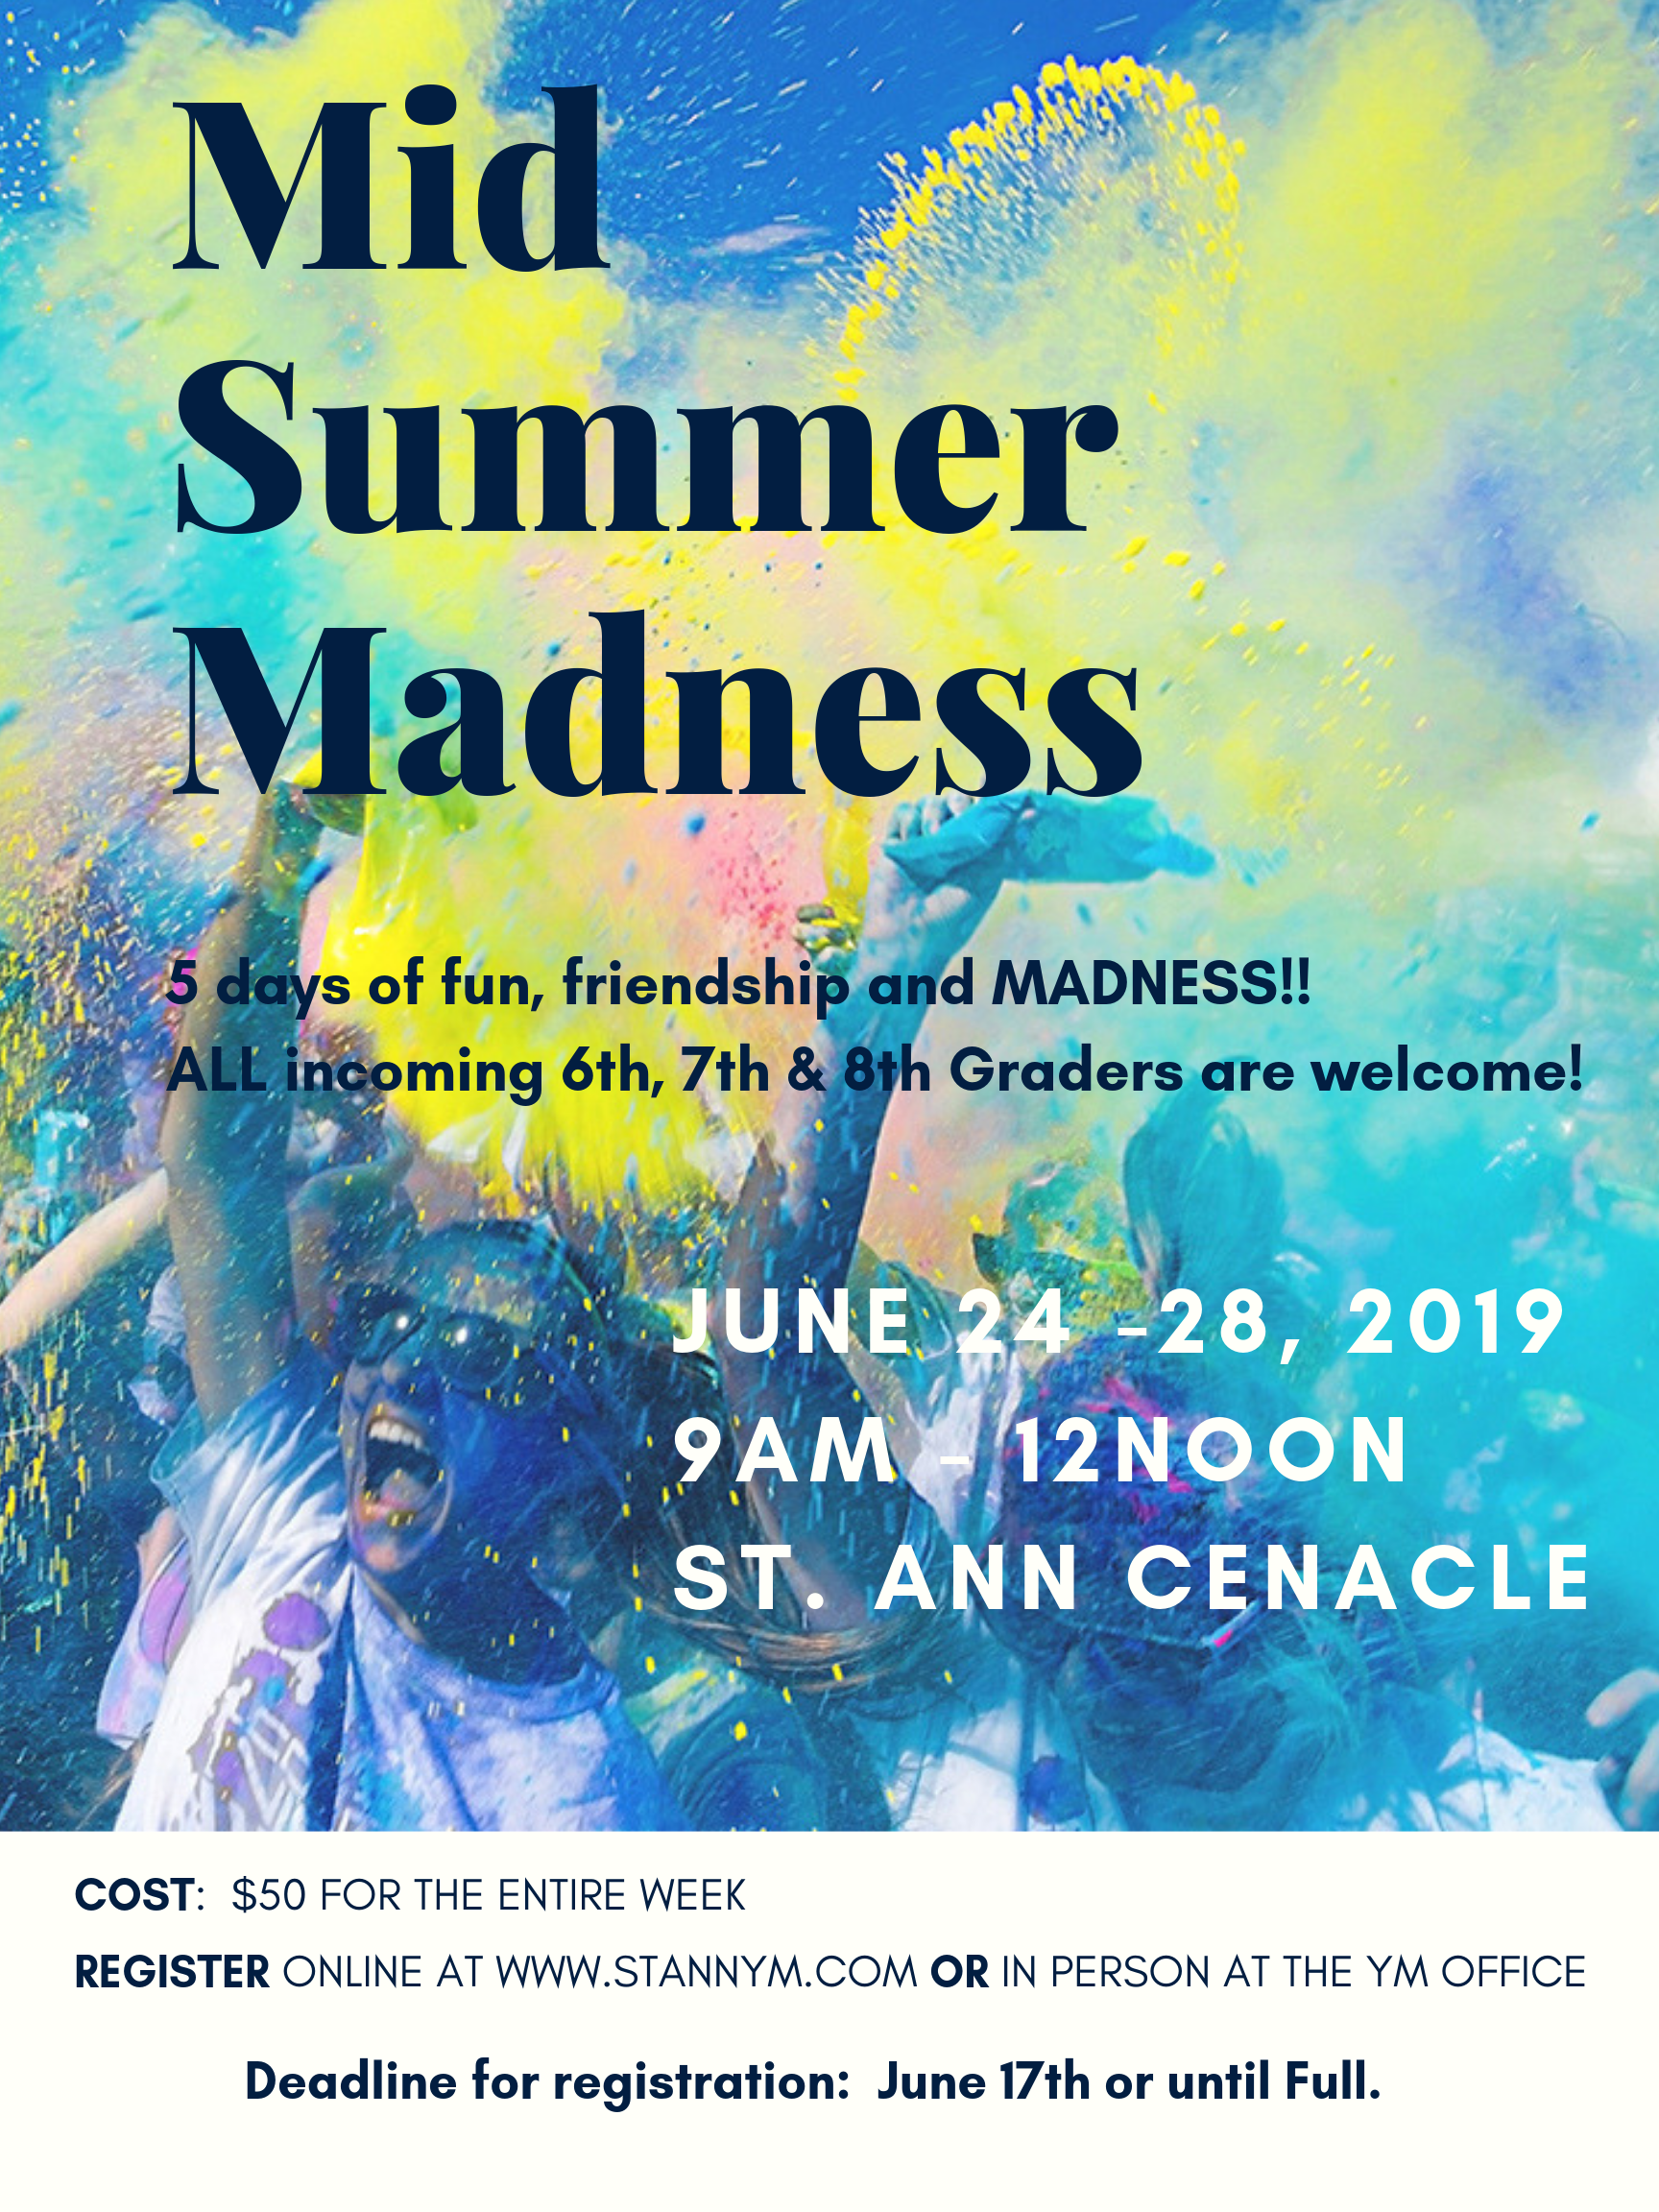
Release, Consent and Medical Info Form

Participant First Name______________________ Last Name ______________________ D.O.B. ____ /_____ /_____

Grade Fall ‘19 (circle one): 6th 7th 8th School _________________________________

Parent/Guardian #1 _________________________________ Mobile Phone #:____________________________

Parent/Guardian #2 _________________________________ Mobile Phone #:____________________________

Email for updates: __________________________________ One friend I would like to be grouped with: _________________________________

T-shirt Size: (Please circle one): Youth Large Adult Small Medium Large XL XXL

ADULT VOLUNTEERS (must be cleared)

Name______________________________________ Home Phone _______________________

Cell Phone _______________________________ Email______________________________________

T-shirt size (Circle One): Adult Small Adult Medium Adult Large Adult XL. Adult XXL Adult XXXL

I want to volunteer (circle one): All week or Circle availability Mon Tue Wed Thur Fri

CONSENT TO PARTICIPATE AND LIABILITY RELEASE
I, the parent/guardian/conservator of grant permission for my son/daughter to participate in MidSummer Madness.

I understand that as parent/guardian/conservator, I remain legally responsible for any personal actions taken by my son/daughter. I recognize the inherent risk associated with the various youth activities that my son/daughter will be participating in. I agree on behalf of myself, my son/daughter named herein, my heirs, successors, and assigns to indemnify, defend, and hold harmless St. Ann Catholic Church, the Roman Catholic Diocese of Dallas, their employees and/or volunteers from any and all claims (unless due to the Sole or Gross NEGLIGENCE of the Parish) for illness, injury, death, and the cost of medical treatment therewith, arising from or in any way connected with my son/daughter participating in this event.

In the event any legal action is taken by either party against the other party to enforce any of the terms and conditions of this release, it is agreed that the unsuccessful party to such action shall pay to the prevailing party therein all reasonable court costs, reasonable attorneys’ fees and expenses incurred by the prevailing party.

AUTHORIZATION OF CONSENT TO TREAT MINOR
I, am the parent guardian or conservator of , a minor, and as such do hereby authorize St. Ann Catholic Church, its youth ministry leaders, employees, contractors and volunteers as agent(s) for the undersigned to consent to any x-ray examination, anesthetic, medical, dental, or surgical diagnosis or treatment, and hospital care which is deemed advisable by, and is to be rendered under the general or specific supervision of any physician or surgeon licensed under the laws of the jurisdiction where such diagnosis or treatment may be given, whether such diagnosis or treatment is rendered at the office of said physician, at a hospital, or at any other location. It is understood that this authorization is given in advance of any specific treatment or diagnosis, but is given to provide authority and power of treatment, or hospital care which the aforementioned physician in the exercise of best judgment may deem advisable. This authorization is given pursuant to the provisions of Chapter 32 of the Texas Family Code. This authorization shall remain effective throughout the specific event dates listed above. In consideration of acceptance of this authorization, but without any time limitation and without any future right of revocation, I hereby release, defend and hold harmless the Parish, the Roman Catholic Diocese of Dallas (Diocese), their officers, directors, agents, employees, volunteers, youth ministry leaders, and contractors from all claims, liabilities and loss in any way arising out of or in connection with or relating to such treatment and treatment decisions.

AUDIO/VISUAL RECORDING AND PHOTOGRAPHY CONSENT (Check one below)
On occasion, video recordings, audio recordings, photographic slides, and photographs are taken of children and youth during church and diocesan sponsored activities. These are utilized in newsletters, websites, event promotion, advertisements and other printed media. As the State of Texas does not prevent audio or video recording or the photographing of children/youth (with the exception of Senate Bill 1, Section 26.009, which deals specifically with school districts), it does encourage parental consent. Additionally, current video recordings and photographs assist law enforcement agencies dealing with the Missing Children’s Program.

I consent / do not consent (check one) to the use of such materials in which my child may appear. I release the staff and volunteers of St. Ann Catholic Church and the Roman Catholic Diocese of Dallas from any liability connected with the use of my child’s picture or audio/video recording as part of any of the above or similar activities.

Youth Participant’s Name:

Insurance Carrier: _____________________________________________________________________________________

Policy Number: ___________________________________ Insurance ID Number: _______________________________

TEEN CURRENT MEDICATION – Initial only one below

_________ This youth takes no medication and will bring no medication with him/her.

_________ This youth takes medication/s and will self-medicate. He/she will bring all such medications necessary, and such

Medications will be clearly labeled. Names of medications and exact dosage and frequencies/times are as listed below:

______________________________________________________________________________________________________

______________________________________________________________________________________________________

_________ This youth takes medication but we would prefer that an Adult Leader dispense medications. I understand that the adult to whom my youth surrenders the medication may not have medical training. At the conclusion of the event, it will be this youth’s responsibility to pick up remaining medication(s), if any. Names of medications and exact dosage and frequencies/times are as listed below:

_______________________________________________________________________________________________________

_______________________________________________________________________________________________________

“OVER THE COUNTER” MEDICATION PERMISSION – Initial one below

_________ No medication of any type whether prescription or nonprescription may be administered to this youth unless the situation is life-threatening and emergency treatment is required.

_________ I grant permission for the following nonprescription medication to be given to this youth:

Tylenol/Acet. Yes __________ No __________ Advil/Ibuprophen Yes __________ No __________

Throat Lozenge Yes __________ No __________ Decongestant Yes __________ No __________

Antacid Yes __________ No __________ Antihistamine Yes __________ No __________

Other ________________________________________ Dosage _______________________________________

Specific Medical Information

Allergic reactions (medications, foods, plants, insects, etc.) _________________________________________________

Any physical limitations: _____________________________________________________________________________

Any other special medical conditions of this youth that we should be aware of?

_________________________________________________________________________________________________

Name of Parent/Guardian/Conservator Phone Number

Address Mobile or Add’l Phone Number

Signature of Parent/Guardian/Conservator Date Signed

Name of Additional Emergency Contact Phone Number

